USD 269
Phased Plan for Reopening

USD 269, along with state and local health authorities, will determine which of the following methods of education best enables our students to receive the safest and most effective learning experience possible. This is a fluid plan, subject to change. The flexibility of this plan allows USD 269 to assess the local health climate and to best adapt to the needs and circumstances of our students and staff.

As of now, USD 269 will reopen for the 2020-2021 school year in-person and on-site observing the guidelines set forth in this document. Parents who wish to keep their child(ren) at home during this time, may choose to enroll in Remote Learning. This option is explained further in this document.

Learning and School Safety Operations
Regardless of the phase, we have identified four priorities that we will focus on throughout the entire process:
- Promote behaviors that reduce spread
- Maintain healthy environment
- Maintain healthy operations
- Prepare for when someone gets sick

Phase 1: On-Site Learning Environment- Students and staff attend on site with enhanced and mandatory health and safety protocols put in place. This will be implemented when there are low levels of community restrictions.
Phase 2: Hybrid Learning Environment- Students may be targeted for stable groups and asked to attend on site in a controlled environment while other students are doing remote learning. This phase may be implemented when there are moderate to high levels of community restrictions.
Phase 3: Remote Learning Environment- Students receive their learning remotely by USD 269 teachers. This is the most restrictive situation when there are high levels of community restrictions. This model could be implemented at a district or building level. This decision will be made at the discretion of Rooks County Health Officials, USD 269 Administration, and the Board of Education.

Confirmed Case in a building, regardless of community transmission—All Phases
- Identify staff/students to be sent home to self-isolate and to allow time to coordinate with local health officials.
- Close building/area of a building for a short period of time to clean and disinfect. This closure may include all extracurricular activities.
- Allow for contact tracing to occur by county health officials with support from the school.
- Communication will be made as to when operations will resume.
- In such a situation, it is critical to maintain confidentiality of the student or staff member as required by American with Disabilities Act and the Family Education Rights and Privacy Act.
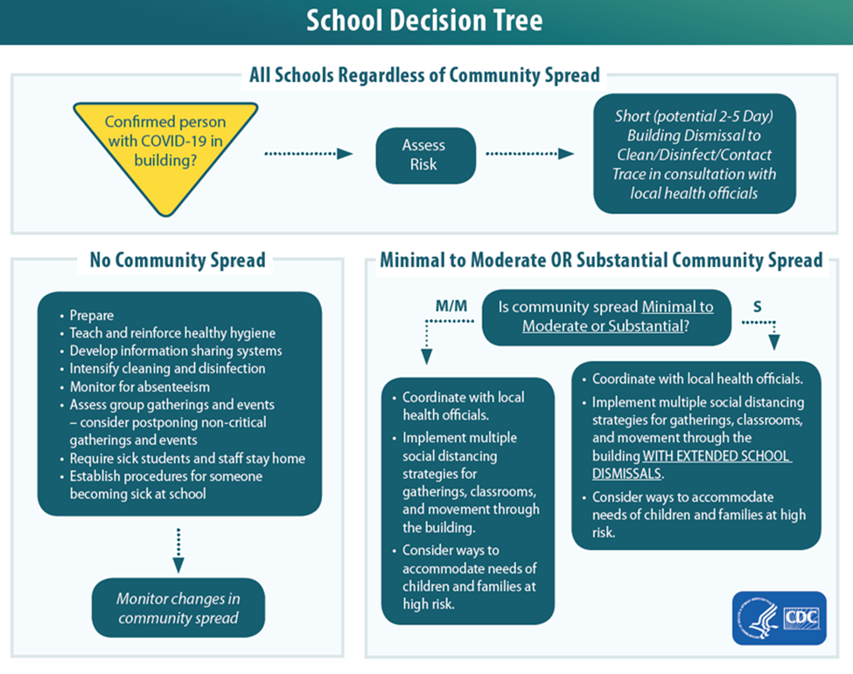
Phase 1
On Site Learning

What to Expect
Instruction: Students and staff return to on-site learning following normal school hours with added health and safety precautions in place.
Students with Exceptionalities: Students who are medically able and willing to return to school receive their typical support and programming. NCKSEC staff will adhere to USD 269 plans for re-opening.
Health and Safety Precautions:
- All students’ and staff temperatures will be taken upon entering the building. Students who ride the bus will receive temperature checks before loading the vehicle.
- No student or staff member will be allowed to attend school with a temperature of 100.4 degrees or higher. Anyone who has a temperature greater than 100.4 degrees will be asked to stay home for 72 hours fever free or 24 hours fever free with a doctor’s note as per county health department guidelines.
- All students and staff will be required to wear a mask, with noted exceptions as outlined by Executive Order 20-59. USD 269 will provide two masks for every student and staff member. (Students and staff will not be required to wear a mask when engaged in activities during which usage is unsafe or impossible, bus drivers will only wear a mask when loading and unloading). Anyone with exceptions to EO 20-59 must have written documentation provided by a MD or DO on file with USD 269.
- Students will report directly to their classrooms upon arrival.
- Students and staff will practice social distancing when possible, maintaining spaces of six feet between individuals.
- Hand washing/sanitizing will take place upon entrance of buildings, cafeteria, and at regular intervals, no less than once every hour throughout the school day.
- Parents/Guardians and visitors will be restricted from entering the building. If they are permitted, they will be required to wear a mask.
- Water fountains will not be available to students, but students will have access to water bottle filling stations. We highly recommend students bring their own water bottles and will be allowed access to them throughout the day.
Classrooms: Furniture will be arranged to have all students face the same direction and allow for social distancing. Students will be assigned seats. The sharing of school supplies/materials will be limited to the greatest extent possible. Hand sanitizers will be available in classrooms. Classrooms will be cleaned at regular intervals throughout the day.
Common Spaces: Access to these areas will be limited to students, staff, and essential personnel. The number of students in office spaces will be limited to maintain social distancing. Hand sanitizing stations will be available in these areas.
Transitions: Due to the limited amount of locker space, students should bring only the necessary school supplies needed for that day. Students will practice social distancing during transitions. Students will be encouraged to use the restroom during class time to limit the number of students in the bathrooms between classes.
Extracurricular: Coaches and sponsors will maintain an attendance roster for activities that take place and use appropriate precautions based on the activity. All other guidelines will be based on KSHSAA Recommendations. All extracurricular participants must be enrolled in our on-site learning environment. Any exceptions must be approved through the administration.
Food Service: Pre-K students will eat breakfast in their classroom. K-5 students will eat in their classrooms. 6-12 students will eat breakfast in the cafeteria and lunch in designated areas throughout the school. Social distancing will take place during breakfast and lunch.
Transportation: Normal service will be provided to eligible students. Masks will be required as outlined in KS Executive Order 20-59. Temperature checks will take place as students load the bus for the morning route, and if elevated (100.4 or higher), the student will not be allowed to ride the bus or attend school that day. Students waiting for the buses at the Palco or Damar schools during morning transportation need to remain in their vehicles or plan to arrive slightly before bus departure. Students will not be able to wait inside the Palco or Damar schools. Bus seats will be assigned and maintained by family units.
Student Arrival: Students and staff will be required to enter through the front entrances at both buildings for temperature checks before entering the school. If a student or staff member has a temperature of 100.4 or higher, they will be sent home immediately without being allowed inside the building. Temperature checks will begin at 7:45 a.m. Please do not arrive before 7:45 a.m. Arrival times for bus riders are subject to change depending on your individual bussing schedule. Once allowed in the building, students will be expected to go straight to their classrooms. Teachers will be available to assist younger students to their classrooms.

Phase 2
Hybrid Learning

Phase 2
Hybrid Learning

What to Expect
This phase will go into effect if some students are required to learn remotely for a period of time due to COVID exposures and contact tracing. This is to ensure students stay at the say pace as their on-site peers.
On-Site Learners: Refer to Phase 1 for details.
Remote Learners: Refer to Phase 3 for details.
Extracurricular: All extracurricular participants must be enrolled in our on-site learning environment. Any and all exceptions must be approved through the administration.

Phase 3

Phase 3
Remote Learning

What to Expect
Instruction: During Phase 3, all USD 269 buildings are closed, and all learning is conducted remotely by USD 269 staff through the use of district, student-issued devices. Students engage in school remotely during regular school hours with daily contact being made by staff via video conferencing. In addition, parents/guardians will be required to complete a remote learning/activity log, equivalent to 6 hours of instructional/activity time per day. Failure to complete work assigned, and/or follow to an agreed schedule may constitute truancy. In accordance with state law, daily attendance will be taken. To ensure learning, grades will be taken and standards will be progressively monitored.
Students with Exceptionalities: Teachers and staff of students with special needs work remotely with them. ICLPs will be developed.
Health and Safety Precautions:
- All USD 269 buildings are closed to all but fundamental staff, who will maintain social distancing of six feet when possible. Masks will be required for fundamental staff on-site.
- Temperatures will be taken for staff upon entering the building for the day.

Classrooms: All USD 269 buildings are closed, and all learning is conducted remotely.
Common Spaces: All USD 269 buildings are closed, and all learning is conducted remotely.
Transitions: All USD 269 buildings are closed, and all learning is conducted remotely.
Extracurricular: All extracurricular participants must be enrolled in our on-site learning environment. In the event the whole district moves into this phase, all USD 269 activities and events are canceled and/or postponed.
Food Service: Food distribution is provided curbside. Meals will be charged according to the student’s paid, reduced, or free lunch status.
Transportation: No services are provided.
Family Choices

What choices do I have for my child(ren)?
Option 1: Attend school based on the current learning phase of USD 269. Phases are determined by county COVID risk factors as outlined by Rooks County health officials and USD 269 administration.

Option 2: Parents who wish to keep their child(ren) at home during this time, may choose this remote learning option. Students attend school remotely as outlined in Phase 3. We ask that students choosing this option commit to it on a quarter by quarter basis. For example, if remote learning is chosen for the first quarter, no changes can be made until the beginning of the second quarter. Students choosing remote learning will not have the opportunity to participate in extracurricular activities sponsored by the school.

APPROVED BY THE USD 269 BOARD OF EDUCATION 8/6/2020

